GraphQL in Detail

Mutaation = updation llike update karna purne data ko USE FILE CLIENT in class-21

Make Mutation in this

STEPS:

1. MAKE SERVER FOR MUTATAION
2. Goto <https://www.apollographql.com/docs/react/data/mutations/#gatsby-focus-wrapper>
3. Follow the steps (use client class-21 wala he)

IMP FOR MUTATION:

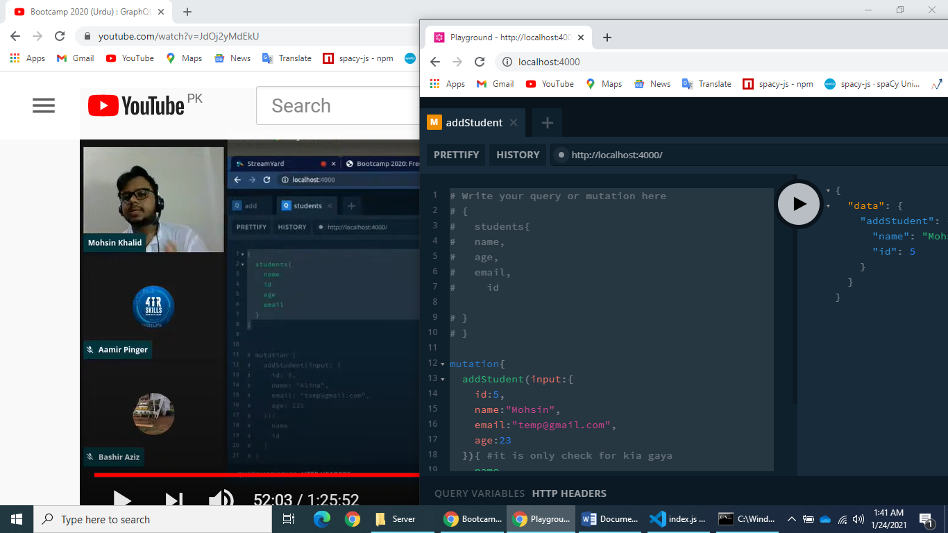

# Write your query or mutation here

# {

# students{

# name,

# age,

# email,

# id

# }

# }

mutation{

addStudent(input:{

id:5,

name:"Mohsin",

email:"temp@gmail.com",

age:23

}){ #it is only check for kia gaya

name

id

}

}

EXTAR:

You can see the client request in network in inspect